Review by Hans Pühringer, OE3HPU

March 1, 2017

For Christmas, OE3DAS visited me with his new FT891. Reason enough to look at the device in more detail.
First of all, no miraculous miracles have arisen. The device will mainly be bought when the small size, the detachable control unit and the possibility of combination with short motor-controlled mobile antennas are decisive factors and not the functional performance data which is the benchmark for home and contest equipment.

Mechanical:
The FT-891 has a size that lies between the FT-817 and the FT-857. This makes it the smallest 100W mobile device for HF bands, which is currently available on the market. The housing and the controls are pleasing and the display has become larger and thus easy to read, the function buttons are well lit and there is a practical mounting bracket.
Who wants the control panel in the cockpit and the head unit elsewhere, can set up with a separation kit accordingly. The rotary knobs (three, one with double function) are Strong and solid. The microphone and its connection type have not changed compared to the FT 857.
The well-known sockets for loudspeakers and remote control or accessories are located behind. A USB socket has also been inserted.

There were changes in electronics:
DSP was established here. The FT891 has become a super with 69 MHz, 450 kHz and 24KHz DSP. It is also a good thing to mention that you have installed a 3kHz roofing filter at the front, which is automatically grounded with the narrowband modes (SSB CW Digi). The bandwidths can now be set at any desired level. Because of the multitude of new functions and setting possibilities, a completely new menu structure had to be created which, in my view, is easier to learn and easier to learn than the previous one.
Some practical features have been re-installed. Thus, for example, neither the performance control of the PA nor the sideband switching is possible without dipping into the main menu and without scrolling around. Especially in Digi-modes, if you want to reduce the power to adapt to the conditions or to the output stage too.
This is not fine. There, however, it also disturbs that the now available USB port does not have a built-in audio codec this becomes the pure remote control socket. Also a “self-acknowledgment” of the tapes and operating modes to be set with the tuning control was introduced with the new menu. If you look a bit too slow, the device jumps to the operating mode you just do not want and you start from the front But the new menu system is quicker and more effective to use, despite the fact that the number of features has increased.
On the transmitter side, the usual 100W (in AM 25W carrier power) are available and there is an excellent cooling system, which is thermally controlled and adapts the speed infinitely to the transmission time and temperature. In the contest mode, you can extend the cooling time by means of a command in the menu.

The Measurements:
1. Receiver:
Like most devices, the FT891 provides an excess of sensitivity. The lowest receivable signal is -140 dBm (measured in 500 Hz bandwidth in the 10 MHz band so because I have a low-noise quartz oscillator).
Less pleasing, although in practice this is not always felt, is the large signal behavior and the purity of the frequency processing. Thus the intermodulation distance of the third order is 20 kHz distance measured at 10 MHz with 500 Hz bandwidth: with 2f2-f1 only 87 dB, and with 2f1-f2 the value is masked by phase noise at approx. 89 dB. The measurement is difficult to perform due to the noise and inaccurate. An IM measurement at 5 kHz distance can be given here because the phase noise.
In the distance is so disturbing that nothing comes out. My quartz oscillators deliver f1 = 10.615MHz and f2 = 10.635MHz and are very low noise so you can measure the phase noise even on very good devices. The phase noise, if we already talk about it, so I have already examined more closely. The feed-in level for 3dB Rauschanstieg by reciprocal mixing is:

A = 100 kHz - 36dBm See IC 751
50 kHz - 40dBm -18dBm
20 kHz - 53dBm -
10 kHz - 59dBm -
5 kHz - 66dBm - 33dBm

The phase noise of the FT891 is unfortunately even a bit worse than the predecessor FT 857 and always worse than the other devices sold at the moment in this class (TS 480, IC 7100, for example). Only please be careful with hasty conclusions: In practice, this interferes a bit in JT 65 with full band coverage and a CW contest. In normal operation rather not (see below). It would be better without much effort. Very funny: There are other ways to get strong signals, such as those that have nothing to do with intermodulation: 3kHz above the IM frequency with a 70dB distance and very loud signals between the two input carriers. I thought of a measurement error, which could have originated by my oscillators. Therefore, the IC 751 A was re-started and checked, if this comes from my construction. No, nothing, 92.5 dB IM3 beautifully symmetrical, not very noisy and no whistles. True, the FT 891 synth is not pure.

Practice Reception: Due to the disappointing measurements one should expect evil. But that does not happen. The receiver is quite usable, has a nice CW sound without DSP artefacts, there is no bloaring effect, even if you hardly two neighboring antennas at a Fieldday used we have.
Which simulates to OE3XMS. In this one test, the otherwise very good IC 7300 is no longer necessary, because the AD converter is hopelessly overrun. The FT891 helps the (less modern) mixer concept and the roofing filter. The SSB RX frequency response is balanced although the heights have been somewhat cut off, everything is easy to understand and the AGC works fine with a sufficiently long time constant. If a station is very close, it becomes somewhat more difficult, despite the excellent separation of the DSP IF filtering. Reason: see above. The built-in loudspeaker is quite acceptable and it does not rattle anything.

2. Power requirement:
Here a lot of scary story (2A at reception) haunted around the net: Error messages! Here are the values, measured at 13.5V.

Power consumption Operating condition:

19 mA - Device connected, switched off
0.98 A - Reception, low volume
1.02 A - Reception, very noisy
3.2 A - Send SSB, PTT pressed, without mod
5 A - Send, CW, 14MHz, 5W
6 A - to 10W
7.8 A - to 20W
10 A - to 40W

3. Transmitter:
The supplied power cable has a too small cross-section for the length. With it, the full output power is not reached. However, the transmission power is 13.5V operating voltage, a short, thick cable with well-contacting fuses, 94 to 98 watts CW depending on the tape. On 160m my unit delivered only 86 W With the cooling there were never problems.

Transmitter intermodulation:
A dreary chapter. The recommendation of the standards would be at least -25dBc for 3rd order. He does not. 18 dB at 80..100W is the highest of emotions. And you can see the ALC ad just a bit. Only under 50W output it becomes acceptable. Does that do what? The most nothing. The modulation is Powerful and sounds good. The IM products only interfere with the others (HI). If you have a good PA, which is content with 30W control, the thing is half as wild. But: Others can do this (see Figure 3 / IC 7300). My IC 735 creates the -25dBc just like that. The FT 857 is also not good (about the same values ​​as above). Other products from Yaesu are better, like the FTDX 1200.
Harmonic suppression:
Here shines our baby: In no area could be determined upper or secondary waves with less distance than 58 dBc.

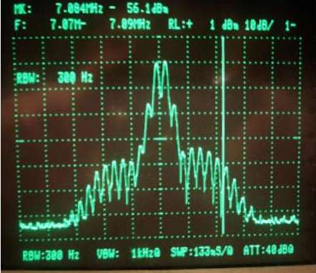  Spectrogram transmitter IM measurement FT 891 | 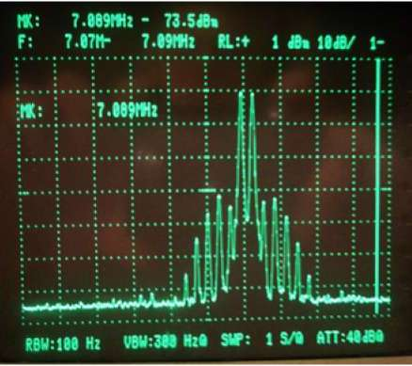  Spectrogram transmitter IM at IC 7300
Conclusion / test evaluation:
Some lines of my report sound quite critical, yes. Again, but it is always clear what is the matter. Little likes the unclean synthesizer and also, despite the improved menu structure still left, handling inconveniences.
Well, I have this device in practice but still very fondly operated. The daily fun shopping fulfilled it.
Complaisant and good. The counter stations always give excellent modulation tracks and even with the auxiliary microphone. A lot of useful functions have been added and compared to the FT 857 there have been advances (AGC, DSP, Roofing filter). The DSP is laudable, because its functions such as bandwidth control, DNR, audio filter and Notch are all satisfied. The possibilities of the 3 band equalizer are also eminently emphasized.
The set is very pleasing in appearance, smaller, has a (a little) large signal receiver with better shrinkage control, a well readable display and shines in the narrowband modes through the roofing filter. The price is reasonable. We talk about the reliability after a few years.
Due to the fact that 2m and 70 cm are missing in the FT 891, it could be that the FT 857 despite its age still longer than universal device.
Now I just want to make it easier to choose if you should buy this mobile transceiver.

